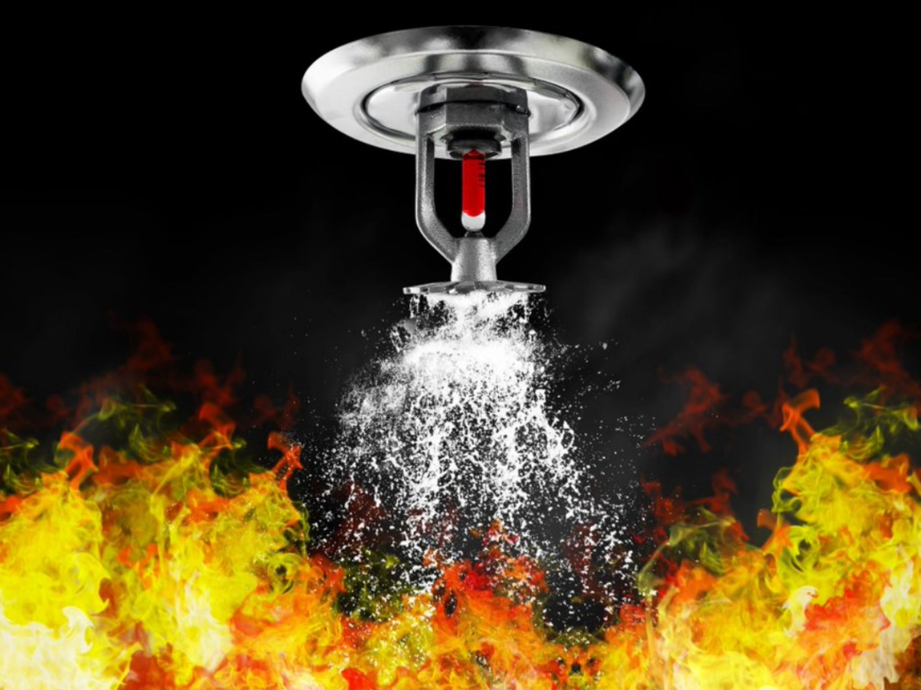

Both presented by
Rob Neale
ICC Certified Instructor

For registration
Contact Jeremy Davis
jeremy.davis@sccfd.org that work
for your business

Location:
1873 Barber Lane
Milpitas, CA 95035
This presentation will explore the role of construction safety codes in the built and natural environment and how those rules affect fire investigation.

Same Day - Session 2
DECEMBER 11, 2025
1:00 PM – 3:00 PM
$25.00 per course
Free for Santa Clara County Fire Investigation Task Force paid members
During post-fire analysis, NFPA 921 recommends fire investigators thoroughly document the fire sprinkler systems’ history, design, installation and performance. This presentation will summarize NFPA 921 requirements and identify key fire sprinkler components that should be evaluated.

WHY CODES MATTER TO FIRE INVESTIGATORS
ICC PROVIDER Course No. 39369

FIRE SPRINKLER SYSTEMS FOR FIRE INVESTIGATORS
ICC PROVIDER Course No. 39368

Same Day - Session 1
DECEMBER 11, 2025
9:00 AM – 12:00 PM

